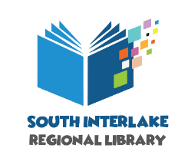

User Feedback Form

Accessible Audiobook Player

This document is available in alternative formats on request.

- Name ________________________________________________________

- Home Library __________________________________________________

- Did you experience an improvement in access to literacy as a result of borrowing this item?
  - Yes
  - No

- How was the explanation of the device provided by the lending library?
  - OK but needs improvement
  - Adequate
  - Good
  - Excellent

- Did you receive customer service from the lending library in an accessible manner?
  - Yes
  - No

- Did you receive a follow-up call from the lending library to help you use the device after you borrowed it?
  - Yes
  - No
- Did you encounter any difficulties using the device or any part of the kit? If so, please state the difficulty. ____________________________________________________________________________________________________________________________________________________________________________________________________________________________________________________

- Did you consult the CD user guide included with the device?
  - Yes
  - No
  - If yes, was the CD User Guide helpful? How might it be improved? ________________________________________________________________________________________________________________

- Did you consult the printed manual included with the device?
  - Yes
  - No
  - If yes, was the printed manual helpful? How might it be improved? ________________________________________________________________________________________________________________

- Would you borrow this device again?
  - Yes
  - No

- Additional user comments _______________________________________________________________________________________________________________________________________________________________________________________

- South Interlake Regional Library sometimes use patron’s comments for promotional, training or reporting purposes. May we use yours?
  - Yes
  - No

